Machine Learning Project
Dataset: Bitcoin Pulse Market Trends Dataset
Name/Surname: Efe Yaşar

1. INTRODUCTION
This study aims to predict Bitcoin’s hourly price movement using financial data from Bitcoin and other major cryptocurrencies. Cryptocurrencies have become an increasingly popular topic in the financial world, and their volatile nature makes them an important area of research. In this project, several machine learning and deep learning algorithms were applied to predict whether Bitcoin’s price would increase or decrease in the next hour. Throughout the study, data preprocessing, feature selection, modeling, and evaluation steps were systematically carried out, and the results were analyzed using various metrics.
2. DATASET DESCRIPTION
The dataset used is titled “Bitcoin Pulse Market Trends and Fear Dataset” and was obtained from Kaggle. It contains hourly open, high, low, and close prices, trading volumes, and financial index data for popular cryptocurrencies like Bitcoin, Ethereum, Dogecoin, and BNB.
The dataset contains 17,515 records and 131 features. Except for the Datetime column, all features are numeric. There are no missing values.
Feature | Value
Number of Records | 17515
Number of Features | 131
Non-numeric Features | ['Datetime']
Missing Values | None
3. DATA PREPROCESSING
The Datetime column was split into year, month, day_of_week, and hour variables to analyze time-based patterns separately. The categorical variables month, day_of_week, and hour were encoded using Label Encoding and One-Hot Encoding methods. Below are the distribution graphs of these variables:
Figure 1. Distribution of the “hour” feature: 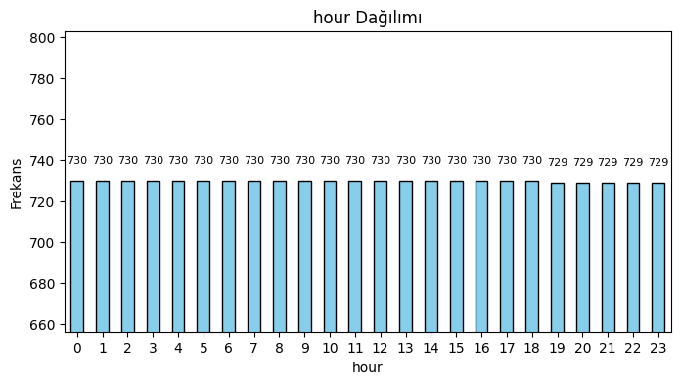
The graph shows that each hour interval has a balanced number of records (around 730 records on average).
Figure 2. Distribution of the “day_of_week” feature: 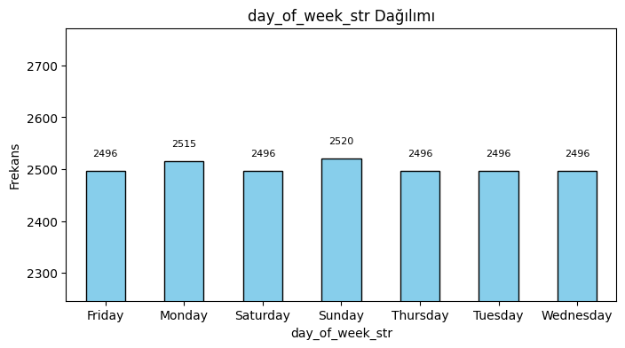
It can be observed that the number of records is similar for each day of the week, with Sunday having the highest number of records.

Figure 3. Distribution of the “month” feature: 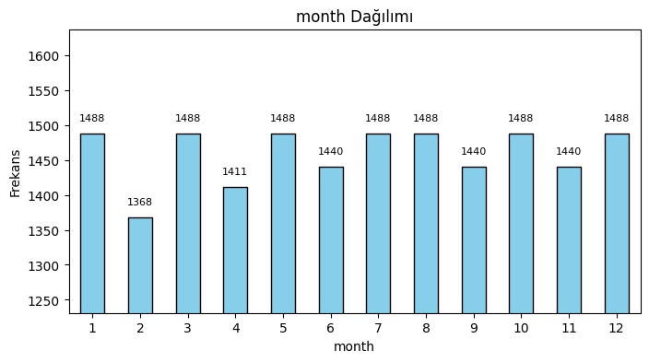
Although there are small differences between months, the data distribution is generally balanced.
Since no missing values were found, no filling or deletion operations were performed.
4. FEATURE SELECTION
A total of 10 different feature selection methods were applied in the study. The first 5 methods are:
- SelectKBest (chi2)
- SelectKBest (f_classif)
- SelectKBest (mutual_info_classif)
- RandomForest Feature Importance
- DecisionTree Feature Importance
Below are the top 3 features selected by each of these methods:
Method | Top 3 Features
SelectKBest (chi2) | month_11, month_11_int, month_12_int
SelectKBest (f_classif) | DOGE_USDT_1h_volume, SOL_USDT_1h_volume, google_trends_bitcoin
SelectKBest (mutual_info) | DOGE_USDT_1h_close, XRP_USDT_1h_high, FTSE_Volume ^FTSE
RandomForest | DOGE_USDT_1h_volume, BNB_USDT_1h_volume, XRP_USDT_1h_volume
DecisionTree | ETH_USDT_1h_volume, XRP_USDT_1h_volume, SOL_USDT_1h_volume

The next 5 methods are: ExtraTrees Feature Importance
- Logistic Regression (L1)
- RFE (Recursive Feature Elimination)
- XGBoost Feature Importance
- LightGBM Feature Importance
Top 3 features selected by these methods:
Method | Top 3 Features
ExtraTrees | SOL_USDT_1h_volume, BTC_USDT_1h_close, DOGE_USDT_1h_volume
Logistic Regression (L1) | ETH_USDT_1h_close, ETH_USDT_1h_open, BTC_USDT_1h_close
RFE | DOGE_USDT_1h_volume, ETH_USDT_1h_open, ETH_USDT_1h_close
XGBoost | IBOVESPA_Open ^BVSP, NASDAQ_Open ^IXIC, month_7
LightGBM | XRP_USDT_1h_volume, SOL_USDT_1h_volume, ETH_USDT_1h_volume

These results show that volume and open-close prices are important features for the models.
4.1 CORRELATION ANALYSIS
A correlation matrix was calculated to visualize the relationships between all numeric features in the dataset.
The following heatmap shows the correlation coefficients between feature pairs:
Figure 4. Correlation Matrix Heatmap: 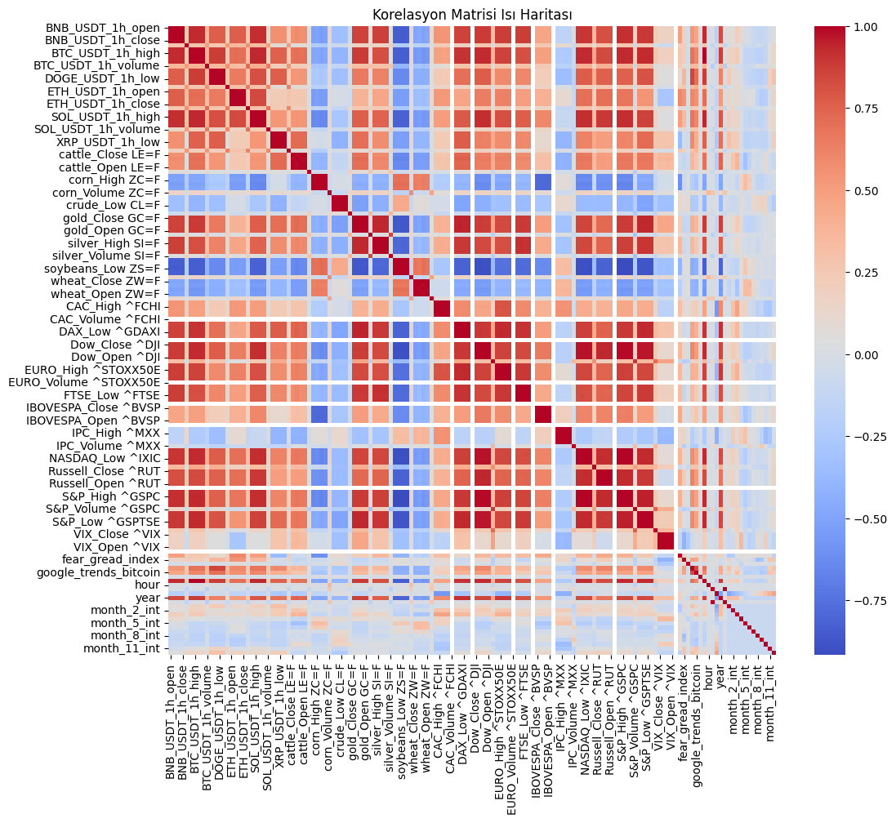

As shown…
high correlations were observed among volume and price features of some cryptocurrencies, while weaker relationships were seen with certain financial indices. This analysis was performed to detect multicollinearity issues and identify significant relationships for modeling.

5. MODELING
Five different machine learning models and three different deep learning models were applied:
Machine Learning Models:
- Decision Tree
- Random Forest
- KNN
- SVM
- Logistic Regression
Deep Learning Models:
- Deep Neural Network (DNN)
- Convolutional Neural Network (CNN)
- LSTM
For each model, accuracy, precision, recall, F1 score, training time, and prediction time were measured.
Model | Accuracy | Precision | Recall | F1 Score | Training Time (s) | Prediction Time (s)
Decision Tree | 0.4996 | 0.5002 | 0.4996 | 0.4997 | 6.69 | 0.0025
Random Forest | 0.5073 | 0.5077 | 0.5073 | 0.5074 | 43.17 | 0.0145
KNN | 0.4730 | 0.4731 | 0.4730 | 0.4731 | 0.0265 | 0.0092
SVM | 0.4981 | 0.4932 | 0.4981 | 0.4862 | 40.99 | 0.0053
Logistic Regression | 0.4941 | 0.4900 | 0.4941 | 0.4858 | 4.57 | 0.0023
DNN | 0.5039 | - | - | - | 45.73 | 0.1283
CNN | 0.5156 | - | - | - | 37.63 | 0.1329
LSTM | MSE:3.78e9 | RMSE:61470 | - | - | 37.09 | 0.4676

6. EVALUATION
Random Forest and CNN models provided the best results. The CNN model achieved the highest accuracy at 51.56\%; however, the confusion matrix showed that the model predicted all examples as the positive class. This artificially boosted recall to 1.0 but kept the overall accuracy close to random guessing.
When comparing the models, although CNN achieved the highest accuracy (0.5156), it failed to distinguish between classes since it predicted everything as positive. The Random Forest model provided more balanced predictions, but its accuracy remained close to 50\%. This suggests that the features in the dataset may not have enough discriminative power for predicting Bitcoin’s price direction.
Random Forest Confusion Matrix:

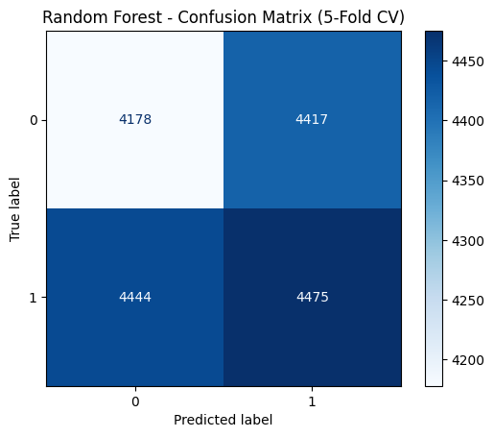
CNN Confusion Matrix:
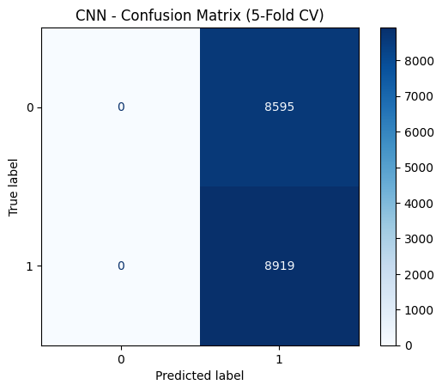

7. CONCLUSION
In this study, various machine learning and deep learning models were applied to predict Bitcoin’s price movement. The selected features focused on volume and price variations. Future work may include adding features like sentiment analysis or blockchain metrics to improve prediction accuracy. The results showed that the current dataset has limited discriminative power for predicting price direction.

8. REFERENCES
- Kaggle – Bitcoin Pulse Market Trends Dataset
- Scikit-learn Documentation
- TensorFlow Documentation
- XGBoost Documentation
- LightGBM Documentation

